Step1:-

Launch browser and navigate to [**https://mysql.com/**](https://mysql.com/)



**Step2:**

**Click on the downloads**



**Step3:-**

**Scroll down the page and select the MySQL Community Edition**

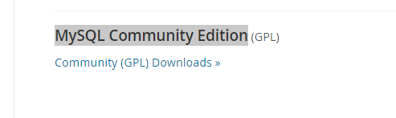

**Step 4:-**

**Click on the “**[Community (GPL) Downloads »](https://dev.mysql.com/downloads/)”

**Step 5:-**

**Click on the download**

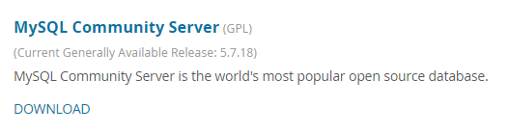

**Step 6:-**

**Scroll Down and click “MY SQL Installer For Windows”**

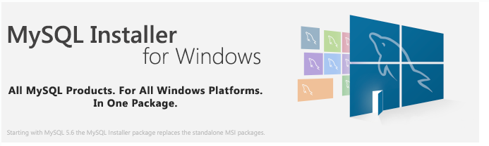

**Step 7:- Download the MSI installer**



(mysql-installer-community-5.7.18.1.msi)

**Step 8:-**

**Once download is completed, please visit the following url to find the steps how to install the “MYSQL”**

[**http://www.wikihow.com/Install-the-MySQL-Database-Server-on-Your-Windows-PC**](http://www.wikihow.com/Install-the-MySQL-Database-Server-on-Your-Windows-PC)

Step 9:-

Once you installation is completed you must download the “MYSQL” Connector from the following site.

<http://www.java2s.com/Code/Jar/m/Downloadmysqlconnectorjar.htm>

Scroll down to the end you will find the below



Step 10:-

Click on it and save the file

Step 11:-Extract the file and configure in the build path of your project